R. Reports Menu: 2. Billing Proof Sheet

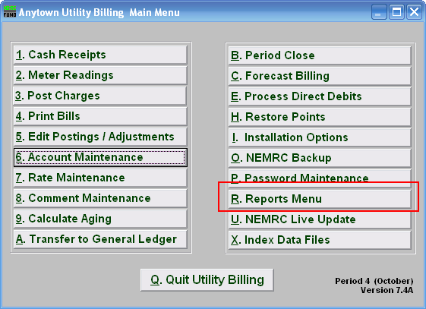
Click on “R. Reports Menu” from the Main Menu and the following window will appear:

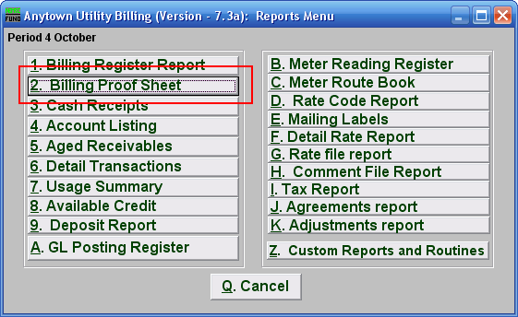
Click on “2. Billing Proof Sheet” from the Reports Menu and the following window will appear:
Billing Proof Sheet

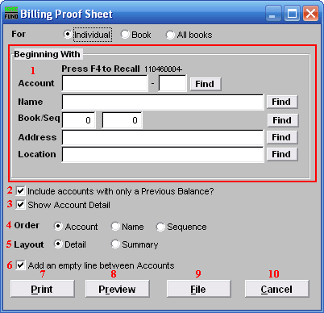
- Beginning With: If you choose “Individual,” choose the account you want to begin with. For additional help on finding accounts, refer to UB GENERAL ACCOUNT LOOKUPS. If you choose “Book,” choose the Book you wish to forecast billing for. If you choose “All Books,” this section will not be available.

- Include accounts with only a Previous Balance?: Click the box to remove accounts that do not have any calculated, but unprinted, billing records.

- Show Account Detail: Account details show information specific to the selection from above.

- Order: Click the circle next to the order you want the information to appear on the report.

- Layout: Click the circle next to “Detail” to show information by service, services are defined in “I. Installation”. “Summary” does not separate information by service.

- Add an empty line between Accounts: Click this box to have a line between accounts for marking up the report or visual appearance.

- Print: Click this button to print this report. Refer to GENERAL PRINTING for more information.

- Preview: Click this button to preview this report. Refer to GENERAL PREVIEW for more information.

- File: Click this button to save this report on this computer. Refer to GENERAL FILE for more information.

- Cancel: Click “Cancel” to cancel and return to the Reports Menu.

